**COB-2021-XXXX** (**XXXX** is the identification number of the final paper)

**Instructions for Formatting Proceedings Papers of the 26th COBEM (TIMES NEW ROMAN, CENTERED, BOLD, SIZE 14)**

(single blank line size 14)

First Author’s Name (Times New Roman, Bold, size 10)

Second Author’s Name (Times New Roman, Bold, size 10)

Institution and address for first and second authors - if the same (Times New Roman, size 9)

e-mails(Times New Roman, size 9)

(single space line, size 10)

Third Author’s Name (Times New Roman, Bold, size 10)

Institution and address for third author (Times New Roman, size 9)

e-mail(Times New Roman, size 9)

(single space line, size 10)

Same format for other authors, if any

(single space line, size 10)

**Abstract.** The abstract should describe the objectives, the context and importance of the research, the methods, the results and the main conclusions of the paper in about 200 words. It should not contain neither formulae nor reference to bibliography. It must be written in only one paragraph. (Times New Roman, italic, size 10)

(single space line, size 10)

**Keywords:** keyword 1, keyword 2, keyword 3 …. (up to 5 keywords, separated with commas) (Times New Roman, italic, size 10)

(single space line, size 10)

1. Introduction (Times New Roman, bold, size 10)

(single space line, size 10)

The purpose of these instructions is to serve as a guide for formatting the **papers** to be published in the proceedings. The proceedings of the 26th COBEM will be published in Adobe™ PDF format.

The papers **MUST** be formatted according to these instructions. The present file can be used as a template for Microsoft Word™. Also, it could be used as a formatting guide to users of other word processors.

The papers are limited to a minimum of **6** pages and a maximum of **10** pages, including tables and figures.

(single space line, size 10)

1. Text format

(single space line, size 10)

The manuscripts should be written in English, typed in A4 size pages, using font Times New Roman, size 10, except for the title, authors affiliation, abstract and keywords, for which particular formatting instructions are indicated above. Single space between lines is to be used throughout the text.

The text block that contains the title, the authors’ names and affiliation, the abstract and the keywords must be indented 0.1 cm from the left margin and marked by a leftmost black line border of width 2 ¼ pt.

The pages must have a top margin of 3 cm and all the other margins (left, right and bottom) must have 2 cm. The body of the text must be justified. The first line of each paragraph must be indented by 0.5 cm. Sufficient information must be provided directly in the text, or by reference to available published work. Footnotes should be avoided. PAGES **SHOULD NOT** BE NUMBERED.

All the symbols and notation must be defined in the text. Physical quantities must be expressed in the SI (metric) units. Mathematical symbols appearing in the text must be typed in *italic* style. Units must be typed in roman style (e.g., kg, m, MJ, kW/m2, instead of *kg*, *m*, *MJ*, *kW/m2*).

Bibliographic references should be cited in the text by giving the last name of the author(s) and the year of publication, according to the following examples: “Recent work (Simas and Di Gregorio, 2019), …” or “Recently, Simas and Di Gregorio (2019), …”. In the case of three or more authors, the form “(Bravo *et al.*, 2018)” should be used. Two or more references having the same authors and publication year must be distinguished by appending “a”, “b”, etc., to the year of publication. For example: “In the works of Santos *et al*. (2013a) and Santos *et al*. (2013b), …”.

Acceptable references include journal articles (Bravo *et al.,* 2018), articles published in conference proceedings (Santos *et al.*, 2013a, 2013b), conference proceedings (Carvalho, 2017), books (Mendonça and Fancello, 2019), Master’s Theses (Campos, 2018) and Doctoral Dissertations or Doctoral Theses (Grando, 2017), patents (Fernandes et al., 2018), reports, when publicly available, (EPE, 2020), websites and specific pages in websites (MLA, 2020), and submitted articles (if the journal is identified).

References should be listed at the end of the manuscript according to instructions provided in Section 4.

(single space line, size 10)

* 1. Section titles and subtitles

(single space line, size 10)

The section headers and sub headers must be aligned at left, typed with Times New Roman, size 10, bold style font. They must be numbered using Arabic numerals separated by points. No more than 3 sublevels should be used. One single line size 10 must be included above and below each section title/subtitle.

(single space line, size 10)

* 1. Mathematical equations

(single space line, size 10)

The mathematical equations must be indented by 0.5 cm from the left margin. They must be typed using Times New Roman (or Cambria Math), *italic*, size 10 pt. font. Arabic numerals must be used as equation numbers, enclosed between parentheses, right-aligned, as shown in the example below. Equations should be referred to either as “Eq. (1)” in the middle of a phrase or as “Equation (1)” in the beginning of a sentence. Matrix and vector quantities can be indicated either by brackets and braces, as in Eq. (1), or in bold style, as in Eq. (2). One blank line must be included above and below each equation. Symbols used in the equations must be defined immediately before or after their first appearance.

“The equation of the dynamical system is written in one of the two forms,

(single space line, size 10)

|  |  |
| --- | --- |
| $\left[M\right]\left\{\ddot{x}(t)\right\}+\left[C\right]\left\{\dot{x}(t)\right\}+\left[K\right]\left\{x(t)\right\}=\{f\left(t\right)\}$, | (1) |

(single space line, size 10)

or,

(single space line, size 10)

|  |  |
| --- | --- |
| $M\ddot{x}\left(t\right)+C\dot{x}\left(t\right)+Kx\left(t\right)=f(t)$, | (2) |

(single space line, size 10)

where $\left[M\right]$ or $M$, $\left[C\right]$ or $C$, and $\left[K\right]$ or $K$ are the mass, dissipation, and stiffness matrices, respectively, and $\left\{\ddot{x}\right\}$ or $\ddot{x}$, $\left\{\dot{x}\right\}$ or $\dot{x}$, $\left\{x\right\}$ or $x$, and $\{f\}$ or $f$ are the acceleration, velocity, displacement and input force vectors, respectively.”

(single space line, size 10)

* 1. Figures and tables

(single space line, size 10)

Figures and tables should be placed in the text as close as possible to the point they are first mentioned and must be numbered consecutively in Arabic numerals. Figures must be referred to either as “Figure 1” in the middle of a phrase or as “Figure 1” in the beginning of a sentence.

(single space line, size 10)

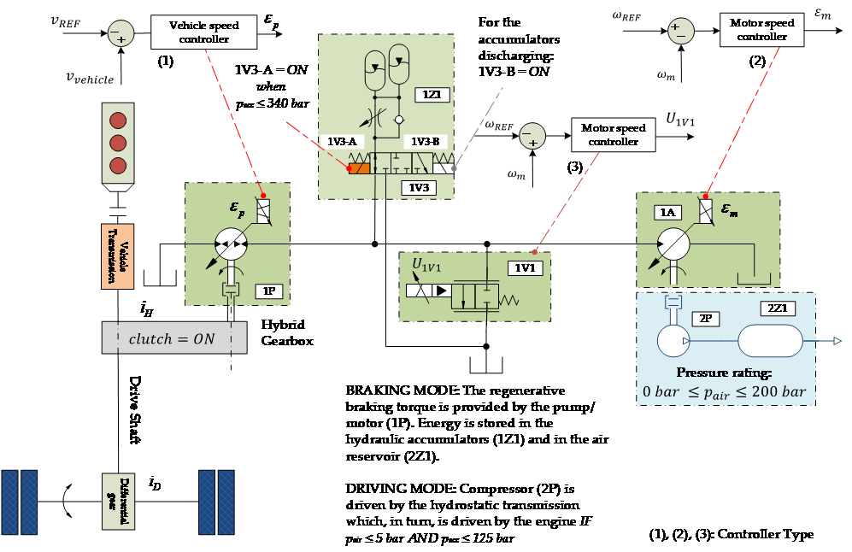

(single space line, size 10)

Figure 1. Schematic diagram of the control strategy.

(single space line, size 10)

The figures, as well as their captions, must be centered in the breadth-wise direction. The captions of the figures should not be longer than 3 lines, centered and in Times New Roman size 10.

One blank line must be left before and after each figure.

The legend for the data symbols as well as the labels for each curve should be included into the figure. Lettering should be large enough for ease reading. All units must be expressed in the S.I. (metric) system.

Color figures and high-quality photographs can be included in the manuscript. To reduce the file size and preserve the graphic resolution, figures must be saved into GIF (figures with less than 16 colors) or JPEG (for higher color density) files before being inserted in the manuscript.

Tables must be referred to either as “Table 1” in the middle of a phrase or as “Table 1” in the beginning of a sentence. The tables themselves as well as their titles must be centered in the breadth-wise direction. The titles of the tables should not be longer than 3 lines. The font style and size used in the tables must be similar (both in size and style) to those used in the text body. Units must be expressed in the S.I. (metric) system. Explanations, if any, should be given at the foot of the tables, not within the tables themselves.

One blank line must be left before and after each table.

The style of table borders is left free. An example is given in Table 1.

Cross references for equations, figures and tables are used in this template. The corresponding labels are Equation, Figure, and Table, respectively.

(single space line, size 10)

Table 1. Experimental results for flexural properties of CFRC-4HS and CFRC-TWILL composites.

Span/depth ratio = 35:1. Average results of 7 specimens.

(single space line, size 10)

|  |  |  |
| --- | --- | --- |
| **Composite Properties** | **CFRC-TWILL** | **CFRC-4HS** |
| Flexural Strength, MPa(1) | 209 ± 10 | 180 ± 15 |
| Flexural Modulus, GPa(1) | 57.0 ± 2.8 | 18.0 ± 1.3 |
| Mid-span deflection at the failure stress, mm | 2.15 ± 1.90 | 6.40 ± 0.25 |

(1) measured at 25°C

(single space line, size 10)

1. Acknowledgements

(single space line, size 10)

This optional section must be placed before the list of references.

(single space line, size 10)

1. References

(single space line, size 10)

The list of references must be introduced as a new section, located at the end of the manuscript. The first line of each reference must be aligned at left. All the other lines must be indented by 0.5 cm from the left margin. All references included in the reference list must have been mentioned in the text.

References must be listed in alphabetical order, according to the last name of the first author. See the following examples:

Bravo, R.R.S., De Negri, V.J., and Oliveira, A.A.M., 2018. “Design and analysis of a parallel hydraulic – pneumatic regenerative braking system for heavy-duty hybrid vehicles”. Applied Energy, Vol. 225, No. 1, pp. 60–77.

Campos, R., 2018. Design of quick couplings for drones and moving vehicles (in Portuguese). Master’s Thesis, Graduate Program in Mechanical Engineering, Federal University of Santa Catarina, Florianópolis, Brazil.

Carvalho, J.C.M., Martins, D., Simoni, R., and Simas, H., 2017. Multibody Mechatronic Systems - Proceedings of the MUSME Conference held in Florianópolis, Brazil, October 24-28, 2017. Mechanisms and Machine Science. Springer International Publishing.

EPE, 2020, *Brazilian Energy Balance 2020*, *Final Report* (in Portuguese), Empresa de Pesquisa Energética EPE, Rio de Janeiro, epe.gov.br/sites-pt/publicacoes-dados-abertos/publicacoes/PublicacoesArquivos/publicacao-479/topico-528/BEN2020_sp.pdf. Accessed 12 January 2021.

Fernandes, R.B., Teixeira, J.S.V., Boeing, F., Pedro Filho, A., Berramashi, E.A., Tounier, M.B., Silva, M.B., and Caminha Junior, L., 2018. “System for monitoring controlled areas in work environments (in Portuguese)”. Patent, INPI - Instituto Nacional da Propriedade Industrial, Brazil, Utility Model, Registry number: BR10201806780403, Deposit: September 04, 2018.

Grando, M.T., 2017. Complacency of cable guided robotic systems (in Portuguese). Doctoral Dissertation, Graduate Program in Mechanical Engineering, Federal University of Santa Catarina, Florianópolis, Brazil.

Mendonça, P.T.R. and Fancello, E.A., 2019. The method of finite elements applied to mechanics of solids (in Portuguese). Editora Orsa Maggiore, Florianópolis.

MLA, 2020. *MLA works cited: Electronic sources (web publications)*. Modern Language Association, Purdue Online Writing Laboratory, Purdue University, https://owl.purdue.edu/owl/research_and_citation/mla_style/mla_formatting_and_style_guide/mla_works_cited_electronic_sources.html. Accessed 12 January 2021.

Santos, D.D., Furtado, G.M., Frey, S.L., Naccache, M.F., and de Souza Mendes, P.R., 2013a. “Flow of elasto-viscoplastic fluids inside a cavity”. In Proceedings of the 22nd International Congress of Mechanical Engineering - COBEM 2013. Ribeirão Preto, Brazil.

Santos, D.D., Furtado, G.M., Frey, S.L., Naccache, M.F., and de Souza Mendes, P.R., 2013b. “Numerical investigation of elastic and viscous effects on inertial viscoplastic fluid flows”. In Proceedings of the 22nd International Congress of Mechanical Engineering - COBEM 2013. Ribeirão Preto, Brazil.

Simas, H. and Di Gregorio, R., 2019. “A technique based on adaptive extended jacobians for improving the robustness of the inverse numerical kinematics of redundant robots”. Journal of Mechanisms and Robotics, Vol. 11, p. 020913.

(single space, size 10)

1. Responsibility notice

(single space, size 10)

The following text, properly adapted to the number of authors, must be included in the last section of the paper:

The author(s) is (are) the only responsible for the printed material included in this paper.